Open Micrsoft Publisher.
At the Getting Started with Microsoft Publisher 2007 page select under Publication Types select Brochures.
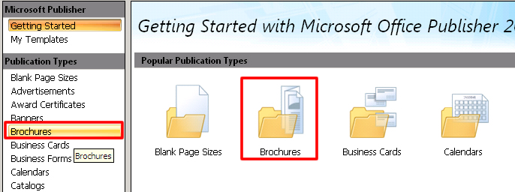
Select Informational for the type of your brochure.
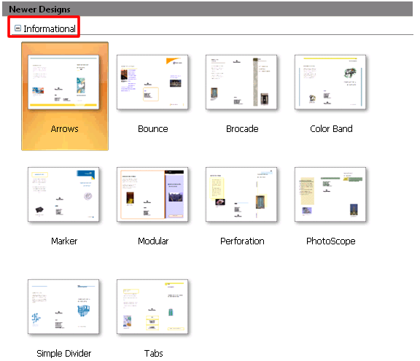
You can customize your brochure by changing the color scheme, font scheme at the Customize options area located at the right hand side of your document window. Do not change the page size options or include a customor address.
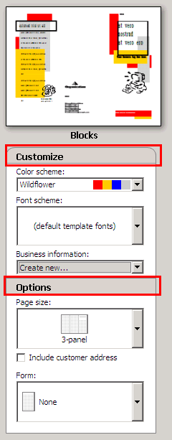
When you have finished customizing your font and color options click the Create button to begin adding the information you included in your worksheet. Make sure you fill in both sides of your brochure!!
Publisher 2003 Instructions:
Directions: The purpose of this activity is to generate a theme park brochure for a variety of parks. Each of you will need to sign up for a different theme park. See your teacher for the park brochure you want to design. When gathering information about your assigned park, make sure that the material you include is interesting and the pictures you use will capture the attention of the intended audience. When planning your brochure, ask yourself what things would draw you to that park. The reason parks make brochures are to encourage people to come visit them. Your goal is to create a brochure that is more appealing than you classmates, getting tourist to want to go to your amusement park over your peers selection. You will also include a map of how to get to the park for people who are not familiar with the area. A useful Website to use for obtaining a map of your destination is Webquest.com. It will actually generate a map for you just by entering the address of your theme park.
The Objects Toolbar will be the main toolbar you will use in this activity. Below is a description of what each of the tools do:
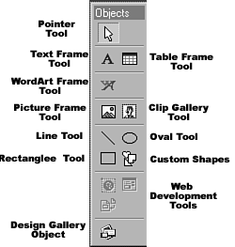
Pointer Tool- Selects lines, shapes, graphics, and text boxes. Selected items can be resized and their attributes changed.
Text Frame Tool-Created text frames. This is what you will use to create the message for your greeting card.
Table Frame Tool-Created table frames.
WordArt Frame Tool-Created a WordArt frame.
Picture Frame Tool-Created a frame in which a picture may be inserted. You would use this tool if you found a picture on the Internet and saved it to your folder.
Clip Gallery Tool-Created a frame in which a piece of clip art my be inserted. Not only can clipart be inserted from the hard drive, but also online by clicking the Clips Online button at the top of the Clip Gallery.
Line Tool-Creates a line.
Oval tool-Creates circular and oval shapes.
Rectangle Tool-Creates rectangular shapes.
Custom Shapes-Creates a wide variety of different shaped boxes (e.g., hearts, lightning bolts, thought boxes).
Web Development Tools-Tools used for the creation of Web pages. Publisher is not a good web publishing software, so these tools will not be covered.
Design Gallery Object-Inserts a wide array of different objects from the Microsoft Publisher Design Gallery (e.g., coupons, advertisements, logos).
The text frame tool on the objects toolbar is used to enter any text in your brochure.
In order to change the font attributes, you would click the following tools on the formatting toolbar:
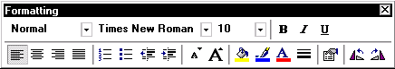
- Include ClipArt, WordArt, or Pictures by clicking on the appropriate tools shown above.
- You can continue to include all words and graphics on all pages of your brochure by clicking on the numbers listed at the bottom of your document screen.
When you have completed this activity, print out your brochure so your classmates can see the finished product.
Click on the "Theme Park Worksheet" for your brochure outline. The things you should include in your brochure are listed on this sheet. Use this as a rough draft in order to better organize your information. Make sure you have the fact sheet checked by your teacher before inserting the information into your Microsoft Publisher Brochure Publication.
Theme Park Worksheet
Choose from the following theme parks. Once your teacher has given you the OK, click on the park name to browse their web site:

Six Flags Over Georgia
Adventure Island Family Fun Center
Blackbeards USA Fun Center
Camden Park Fun Center
Canobie Lake Park
Fantasy Island
Joy Land Park
Knights Action Park
Lightwater Valley
Magic Forest Family Fun Park
Laff in the Dark
Drayton Manor
Wonderland Sidney
Paramount's Kings Island
Open Microsoft Publisher. Choose the informational brochure you wish to use to construct your state's travel information. Make sure you use enough graphics to make it appealing to someone who is looking for a place to visit. Also, include a road map of the area of the state along with directions on how to get there. Include all the information stored in your Theme Park Worksheet (you do not need to include all state graphics, just the ones you think would enhance the look of your brochure). Assign the brochure a name that reflects the name of your theme park.

